**BAHRIA UNIVERSITY (KARACHI CAMPUS**)

ASSIGNMENT # 3 – FALL SEMESTER – 2022

Computer Communication and Networks (CEN-223)

Class: **BSE-5B** Submission Deadline: **30/12/2022**

Course Instructor: **Engr. Mahawish**  Max Marks: **05 marks**

Group Members: Talha Zafar 02-131202-080

Muaz Shahzad 02-131202-081



Question 1**:**

**Instructions: [CLO 6]**

**1. The activity is a Problem Based Learning and a group effort (Max. 4 members).**

**2. Write group member names and registration number under report title.**

**3. The report must be uploaded in LMS.**

Prepare a 15 - 20 report slides in MS power point that would propose a solution for a real-

world problem while employing the Internet of Things (IoT) paradigm. A list of suggested real-

world challenges are provided below from which the students may choose or bring their own

problem to solve. However, you can only work on the report topic after being approved by

the course instructor.

The group needs to present that how IoT can help in solving the problem at hand. While finding

a suitable solution, the learning process should require students to investigate and critically

analyze the communication technologies available under the umbrella of IoT. This exercise

would require group activity where collaboration and group discussions should be involved.

Architectural diagrams, system design, hardware/software requirements, deployment

requirements, communication technologies along with other technical details should be

addressed. The report content should be technical in nature, i.e. going with the general

patterns adopted in the relevant course, Data Communication & Networking.

Technical contents of the report can only be prepared after conducting a thorough

investigation regarding the concerned topic. Each member is required to present his/her part,

where the report will be followed by cross-questioning from the course instructor and

session guest (if any). All student should have knowledge regarding the complete contents within

the report rather than focusing of the contents of his/her part only. Report MUST be

self-made, where its emailed softcopy will be checked for plagiarism.

Note: one topic can only be taken by one group at a time.Scenario #1: IP Allocation in a MAN

You are tasked by your supervisor with assigning IP addresses for your new MAN

(Metropolitan Area Network), which consists of 8 different buildings, each building will have

255 workstations. Your supervisor tells you to only use as much of the 164.10.0.0 network

as you need. Your supervisor will assign the IP addresses to the serial interfaces using a

different network. You will need to determine the following four items for each of the eight

buildings:

A) Subnet masks

B) Network addresses

C) Broadcast address for each subnet

D) Valid host ranges on each subnet

Scenario #1: IP Allocation in a MAN

You are tasked by your supervisor with assigning IP addresses for your new MAN

(Metropolitan Area Network), which consists of 8 different buildings, each building will have

255 workstations. Your supervisor tells you to only use as much of the 164.10.0.0 network

as you need. Your supervisor will assign the IP addresses to the serial interfaces using a

different network. You will need to determine the following four items for each of the eight

buildings:

A) Subnet masks

B) Network addresses

C) Broadcast address for each subnet

D) Valid host ranges on each subnet

Scenario #1: IP Allocation in a MAN

You are tasked by your supervisor with assigning IP addresses for your new MAN

(Metropolitan Area Network), which consists of 8 different buildings, each building will have

255 workstations. Your supervisor tells you to only use as much of the 164.10.0.0 network

as you need. Your supervisor will assign the IP addresses to the serial interfaces using a

different network. You will need to determine the following four items for each of the eight

buildings:

A) Subnet masks

B) Network addresses

C) Broadcast address for each subnet

D) Valid host ranges on each subnet

Scenario #1: IP Allocation in a MAN

You are tasked by your supervisor with assigning IP addresses for your new MAN

(Metropolitan Area Network), which consists of 8 different buildings, each building will have

255 workstations. Your supervisor tells you to only use as much of the 164.10.0.0 network

as you need. Your supervisor will assign the IP addresses to the serial interfaces using a

different network. You will need to determine the following four items for each of the eight

buildings:

A) Subnet masks

B) Network addresses

C) Broadcast address for each subnet

D) Valid host ranges on each subnet

Prepare a report in MS word that would propose a solution for a real-world problem while employing the Internet of Things (IoT) paradigm. A list of suggested real-world challenges is provided below from which the students may choose or bring their own problem to solve. However, you can only work on the report topic after being approved by the course instructor.

The group needs to present that how IoT can help in solving the problem at hand. While finding a suitable solution, the learning process should require students to investigate and critically analyze the communication technologies available under the umbrella of IoT. This exercise would require group activity where collaboration and group discussions should be involved. Architectural diagrams, system design, hardware/software requirements, deployment requirements, communication technologies along with other technical details should be addressed. The report content should be technical in nature, i.e. going with the general patterns adopted in the relevant course, Data Communication & Networking.

Technical contents of the report can only be prepared after conducting a thorough investigation regarding the concerned topic. Each member is required to present his/her part, where the report will be followed by cross-questioning from the course instructor and session guest (if any). All students should have knowledge regarding the complete contents within the report rather than focusing of the contents of his/her part only. Report MUST be self-made, where its emailed softcopy will be checked for plagiarism.

Note: one topic can only be taken by one group at a time.

List of Suggested Real-World Problems:

1. Monitoring patients’ health remotely.

2. Monitoring surrounding environments for CO2 emission.

3. Monitoring electric consumptions within a house.

4. Monitoring the health of machines within a production plants.

5. Monitoring gas distribution pipelines for leakage and damages.

6. Monitoring agriculture fields for plants health.

7. Monitoring goods shipment, warehouse storage and logistics.

8. Monitoring health of bridges, buildings and other structures.

9. Monitoring forests for wildfire and other hazardous materials.

10. Improving safety for vehicles on the road.

Scenario #1: IP Allocation in a MAN

You are tasked by your supervisor with assigning IP addresses for your new MAN

(Metropolitan Area Network), which consists of 8 different buildings, each building will have

255 workstations. Your supervisor tells you to only use as much of the 164.10.0.0 network

as you need. Your supervisor will assign the IP addresses to the serial interfaces using a

different network. You will need to determine the following four items for each of the eight

buildings:

A) Subnet masks

B) Network addresses

C) Broadcast address for each subnet

D) Valid host ranges on each subnet

Scenario #1: IP Allocation in a MAN

You are tasked by your supervisor with assigning IP addresses for your new MAN

(Metropolitan Area Network), which consists of 8 different buildings, each building will have

255 workstations. Your supervisor tells you to only use as much of the 164.10.0.0 network

as you need. Your supervisor will assign the IP addresses to the serial interfaces using a

different network. You will need to determine the following four items for each of the eight

buildings:

A) Subnet masks

B) Network addresses

C) Broadcast address for each subnet

D) Valid host ranges on each subnet

Scenario #1: IP Allocation in a MAN

You are tasked by your supervisor with assigning IP addresses for your new MAN

(Metropolitan Area Network), which consists of 8 different buildings, each building will have

255 workstations. Your supervisor tells you to only use as much of the 164.10.0.0 network

as you need. Your supervisor will assign the IP addresses to the serial interfaces using a

different network. You will need to determine the following four items for each of the eight

buildings:

A) Subnet masks

B) Network addresses

C) Broadcast address for each subnet

D) Valid host ranges on each subnet

Scenario #1: IP Allocation in a MAN

You are tasked by your supervisor with assigning IP addresses for your new MAN

(Metropolitan Area Network), which consists of 8 different buildings, each building will have

255 workstations. Your supervisor tells you to only use as much of the 164.10.0.0 network

as you need. Your supervisor will assign the IP addresses to the serial interfaces using a

different network. You will need to determine the following four items for each of the eight

buildings:

A) Subnet masks

B) Network addresses

C) Broadcast address for each subnet

D) Valid host ranges on each subnet

**Topic:**

**Monitoring agriculture fields for plants health.**

**Abstract**

Smart farming is a trend that has highlighted the use of information and communication technology in machinery, equipment, and sensors in network-based hi-tech farm supervision cycles. Innovative technologies, such as the Internet of Things (IoT) and cloud computing, are on the horizon to stimulate growth and launch the usage of robotics and artificial intelligence in farming. Such radical departures are upsetting established agricultural practices while also posing several obstacles. This study explores the techniques and equipment utilized in wireless sensor applications in IoT agriculture, as well as the predicted problems encountered when integrating technology with traditional farming practices. Furthermore, this technical knowledge is useful to growers during crop times ranging from planting to harvest, and applications in packing and transportation are being researched.

**Introduction**

A measure of ecofriendly food production's persistence and sustenance is called sustainable agriculture to sustain farmers and resources, sustainable agriculture promotes farming methods and practices. It is economically viable, enhances land biodiversity, preserves water resources, decreases soil degradation, and assures a natural and healthy environment.

Sustainable agriculture is crucial for protecting natural resources, stopping the extinction of species, and lowering greenhouse gas emissions.

Crop rotation, nutrient deficit control in crops, pest and disease control, recycling, and water harvesting are the primary achievements of smart farming in terms of sustainable agriculture, resulting in a safer environment overall. Living species rely on biodiversity and are contaminated by waste emissions, fertilizer, and pesticide use, degraded dead plants, and so on. Greenhouse gas emissions have an impact on plants, animals, humans, and the environment, necessitating a better climate for living things.

**Society**

**Sustainable Agriculture**

**Environment Energy**

* The Internet of Things (IoT) is a technology that allows equipment to communicate with one another remotely to accomplish smart farming. The Internet of Things has begun to influence a wide range of industries, including health, trade, communications, energy, and agriculture, to improve efficiency and performance across all markets.
* IoT technologies play an important part in many farming activities, including the use of communication infrastructure, data collecting, smart objects, sensors, mobile devices, cloud-based intelligent information, decision-making, and automation.

**Role of IOT in monitoring agriculture fields for plants**

* The Internet of Things technology can monitor plants and animals and remotely gets data from mobile phones and devices.
* Sensors and devices may enable farmers to forecast production levels and monitor the weather.
* More than ever before, the IoT can be involved in water harvesting, monitoring, and controlling flow amounts, determining the quantity of water needed by crops, timing of supply, and water conservation.
* Sensors and cloud connectivity using the gateway can be used to remotely check the status and water delivery based on soil and plant requirements.
* Farmers cannot personally monitor and inspect every plant to rectify nutrient shortages, pests, and diseases, but IoT technology is still impactful and can lead farmers to a significant milestone in industrial agriculture.

**Impact on Communication infrastructure**

The advancement of IoT technology can have a significant impact on the farming sector, particularly through its communication infrastructure. Connecting smart things, remotely extracting information, employing Vehicles and sensors via mobile devices and the internet, cloud-based intelligent analysis, interfacing, decision formation, and agricultural automation have all been part of this. These abilities have transformed the agriculture industry in terms of resource management, climate control, and crop production improvement.

**Technologies**

Robots, drones, remote sensors, and computer imagery, combined with ever improving machine learning and analytical tools, can be used in agriculture to monitor crops, survey, and map fields, and provide data to farmers for sensible farm management plans, saving both time and money.

The following are some of the advantages of implementing modern technology - Internet of Things in Agriculture:

**Climate Conditions:**

Climate is extremely important in agriculture. Inadequate climate knowledge also has a negative impact on crop production quantity and quality. However, IoT technologies allow you to monitor the weather in real time. Sensors are installed both within and outside of agricultural areas. They collect data from the environment, which is then utilized to select crops that can grow and thrive in the specific climatic circumstances. The entire IoT ecosystem is comprised of sensors capable of reliably detecting real-time meteorological variables such as humidity, rainfall, temperature, and others.

There are several sensors available to detect all these parameters and adjust them to meet your smart farming needs. These sensors monitor the crop's condition as well as the surrounding weather. If any unusual meteorological conditions are discovered, a warning is issued. The requirement for personal presence during disruptive meteorological circumstances is minimized, which boosts production and allows farmers to gain more agricultural benefits.

**Precision Farming:**

Precision agriculture/farming is one of the most well-known IoT applications in agriculture. It improves the precision and control of farming practices by implementing smart farming applications such as animal monitoring, vehicle tracking, field observation, and inventory monitoring. Precision farming's purpose is to analyze data collected by sensors and respond accordingly. Precision farming enables farmers to produce data using sensors and analyze that data to make educated and timely decisions. Precision farming techniques such as irrigation management, livestock management, vehicle tracking, and many more play an important role in enhancing efficiency and effectiveness. Precision farming allows you to analyze soil conditions and other associated data to boost operational efficiency. Not only that, but you can also detect the real-time operating characteristics of the connected devices to identify water and nutrient levels.

### Smart Greenhouse:

IoT has enabled weather stations to autonomously modify climate conditions based on a specific set of instructions, making our greenhouses smart. The usage of IoT in greenhouses has reduced the need for human interaction, making the entire process more cost-effective while also enhancing accuracy. For example, employing solar-powered IoT sensors to construct sophisticated and low-cost greenhouses. These sensors capture and send real-time data that aids in the exact monitoring of the greenhouse status. Water use and greenhouse gas emissions can be tracked using sensors and alerted via email or SMS. IoT is used to do automatic and smart irrigation. These sensors aid in providing data on pressure, humidity, temperature, and light levels.

**Agricultural Drones:**

Technological improvements have nearly completely altered agricultural operations, with the introduction of agricultural drones being the most recent disruption. Aerial and ground drones are utilized for crop health evaluation, crop monitoring, planting, crop spraying, and field analysis. Drone technology has given the agriculture industry a boost and makeover with proper strategy and planning based on real-time data. Drones equipped with thermal or multispectral sensors locate locations that require irrigation adjustments. Sensors show crop health and calculate the vegetation index once the crops begin to grow. Smart drones eventually minimized the environmental impact. The end effect has been a tremendous reduction and much reduced chemical reaching the groundwater.

**Internet of Things (IoT) basic Architecture**

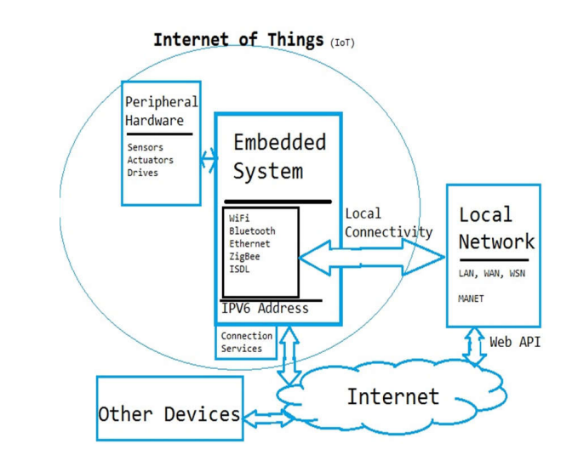

**Typical IoT for agriculture system**

A typical IoT for agriculture system consists of the following:

1. Measurement device
2. Data transmission,
3. Data storage and analytics
4. Feedback and implementation
5. Project structure and support

The device layer consists of a sensor to measure the parameter of interest (e.g., soil moisture) and the electronics necessary to support its functions. Devices are arranged in a topology and connected to a gateway using a communication protocol in the data transmission layer. Broad coverage of cellular networks allows for frequent, and in some cases near real-time, data transmission. Individual or aggregated measurements are received by a server where they can be queried, cleaned, and analyzed. Relevant insights are fed back to an end-user or other IoT devices to inform decisions and prompt actions.

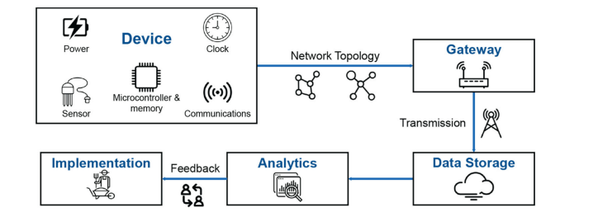

**System Model**

Agriculture is regarded as the foundation of human life because it is the primary source of food grains and other raw materials. It is critical to the country's economic growth. It also provides a big number of job chances to the people. Growth in the agriculture sector is required for the country's economic development. Unfortunately, many farmers continue to adopt traditional farming methods, resulting in low crop and fruit yields. However, everywhere automation has been adopted and humans have been replaced by automated machines, the yield has increased.

Agriculture-related issues have traditionally hampered the country's progress. The only solution to this challenge is smart agriculture, which involves upgrading old agricultural processes.

The Soil Moisture Sensor uses capacitance to measure the water content of soil (by measuring the dielectric permittivity of the soil, which is a function of the water content). Simply the sensor is inserted into the soil to be tested, and the volumetric water content of the soil is reported in percent. Level sensors detect the level of liquids and other fluids and fluidized solids, including slurries, granular materials, and powders that exhibit an upper surface. DHT11 Temperature & Humidity Sensor features a temperature & humidity sensor complex with a calibrated digital signal output, it ensures high reliability and excellent long-term stability. A rain sensor or rain switch is a switching device activated by rainfall. There are two main applications for rain sensors. The first is a water conservation device connected to an automatic irrigation system that causes the system to shut down in the event of rainfall. The second is a device used to protect the interior of an automobile from rain and to support the automatic mode of windscreen wipers. The PIR sensor itself has two slots in it, each slot is made of a special material that is sensitive to IR. The lens used here is not really doing much and so we see that the two slots can 'see' out past some distance (basically the sensitivity of the sensor). When the sensor is idle, both slots detect the same amount of IR, the ambient amount radiated from the room or walls or outdoors. When a warm body like a human or animal passes by, it first intercepts one half of the PIR sensor, which causes a positive differential change between the two halves. When the warm body leaves the sensing area, the reverse happens, whereby the sensor generates a negative differential change. These change pulses are what is detected.

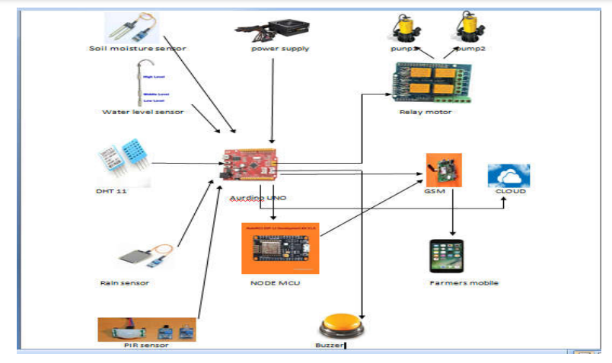

**LoRa Based WSN for Precision Agriculture**

As illustrated in the figure, a LoRa-based WSN is given. The star-topology network contains three sorts of components: end-devices, gateways, and network servers. Sensors/actuators, a LoRa transceiver, and a LoRa receiver comprise the end-devices. Their primary duty is to either upload sensing data to the gateway via LoRa transmitter or receive command messages from the gateway via LoRa receiver. Gateways act as a bridge between end-devices and network servers; Gateways are essentially bidirectional relays or protocol converters. Gateways route raw data frames from end-devices to network servers using a faster Ethernet backhaul link. The network server oversees copying and decoding sensing packets supplied by end-devices, as well as creating decision-making packets to be transmitted back to the end-devices. In contrast to cellular-based NB-IoT networks, end-devices in a LoRa network are not affiliated with a single gateway to get network access; that is, the same packet can be received (or forwarded) by more than one LoRa gateway.

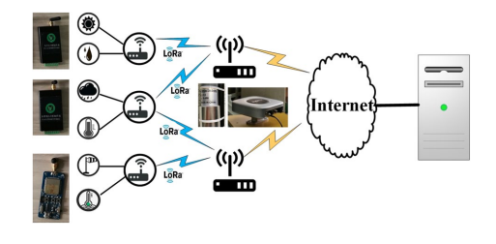

**ZigBee Based WSN for Precision Agriculture**

The ZigBee network is composed of three topological structures: star, tree, and mesh. The tree topology, as opposed to the other two, offers the advantages of high connection and low routing overhead, making it more ideal for agriculture periodic monitoring and other applications. The ZigBee-based tree networking topology shown in Fig. 5 is a highly reliable, energy-efficient, and low-cost solution that has been widely utilized in agriculture to monitor various environmental and soil data.

There are three types of nodes that can be configured in this tree topology network: end-device, router, and coordinator. Their configuration is handled by the ZigBee Module, as shown in Fig. The acquired data (such as air temperature, humidity, and soil moisture) from sensors and end-devices is wirelessly communicated to the coordinator via routers, and then relayed to the network server using GPRS.

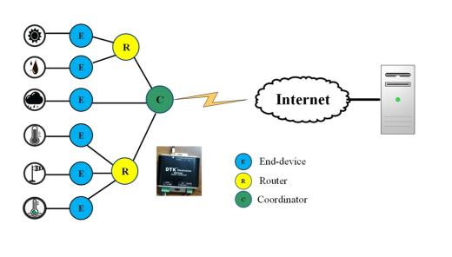

**Conclusion:**

IoT-enabled agriculture has aided in the implementation of cutting-edge technical solutions to time-tested expertise. This has aided in closing the gap between production, quality, and quantity yield. Data Ingestion ensures quick action and minimal crop damage by acquiring and importing information from various sensors for real-time usage or storage in a database. Produce is processed faster and delivered to supermarkets in less time, thanks to seamless end-to-end intelligent operations and better business process execution.